Lovely Professional University

Chaheru, Punjab

**A**

**Final Report**

**On**

**Stamp Collection Website**

**For The Course**

**Internet Programming Laboratory (CSE-326)**

Submitted by-

**Vinay Tiwari** (Roll no. RK19HAA72)

**Puvvala Ram Narayana** (Roll no. RK19HAB34)

**Gaurav Pandey** (Roll no. RK19HAB35)

Guided by-

**PROF. Manu Bali**

Submitted to-

**Lovely Professional University, Chaheru Punjab**

**For Academic Year**

**(2019-2020)**

**(2nd Semester)**

**CONTENT**

|  |  |
| --- | --- |
| **Sr no.** | **Topic** |
| **1** | **Introduction** |
| **2** | **Flow-Chart** |
| **3** | **Page Description(Home Page)** |
| **4** | **Register Page** |
| **5** | **Explore More** |
| **6** | **Contact us** |
| **7** | **Services** |
| **8** | **FAQ Page** |
| **9** | **Selling Stamps** |
| **10** | **Buying Stamps** |
| **11** | **Payment Portal** |
| **12** | **Code Description** |
| **13** | **Contribution** |

**INTRODUCTION**

The purpose of the project, **STAMP COLLECTING WEBSITE** is to provide general information to the visitors that may be interested in collecting stamps and to provide the specialized information needs of more advanced stamp collectors and philatelists.

This website provides plenty of features to its user. Among them two most important of them are mentioned below:

* **STAMP SELLING**
* **STAMP BUYING**

***STAMP SELLING*** is an important feature introduced in this project. The seller has to follow some basic steps if he/she wants to sell their stamps to our company **(CLATUS)**. We ensure our entire user that their data is protected by us. Sellers are asked to provide basic information to us. For example: Name, User Id, name of the stamp which they want to sell, their PAYTM number and at last some details about their stamp. Once they fill all these information and submit to us, all these information are going to be stored in a text file and get downloaded in the system.

***STAMP BUYING*** is the second most important feature of our website. We provide some of the rare and antique stamps to our user. We accept payment only from internet banking. Buyer can select the stamp which he/she want to buy. Buyers are asked to provide to provide us some information which includes their user id, phone number, email, Account details, etc... All these details are copied in a text file and it will be provided to buyer as a proof. Once user submits the information to our website we will contact them by their email or phone number and we ask address in which these stamps are to be delivered. Time taken for delivery depends upon the address provided to us.

**Platform used:**

This project is made with the help of *HTML*, *CSS* and *Java Script*. There are total nine webpage in our project and each webpage is made with the help of one HTML file and one CSS file. In of the page an external file for Java Script is used.

***HTML*** stands for Hyper Text Markup Language. It is the most basic building block of web. It defines the meaning and structure of web content. As mentioned earlier, our project consist total of nine webpage. They are:

* Home page
* Explore more
* Register
* Contact us
* FAQ
* Stamp Selling
* Stamp Buying
* Buy Now
* Services

***CSS*** stands for Cascading Style Sheet. It is a style sheet language used for describing the presentation of a document written in markup language like HTML. There are nine CSS file corresponding to each HTML file. We used CSS in our project for adding different styles and images in our webpage because it makes work simpler and reduces bulkiness in one file.

***Java Script*** is a programming language that conforms to the *ECMAScript* specification. It is high-level, often just-in-time compiled, and multi-paradigm.

**FLOW-CHART**

**HOME PAGE**

**BUY NOW**

**BUYING STAMPS**

**SELLING STAMPS**

**CONTACT US**

**FAQ**

**SERVICES**

**HOME**

**EXPLORE MORE**

**REGISTER PAGE**

**PAGE DESCRIPTION**

H O M E P A G E

This is first page of our website. It includes a logo which is designed from logo maker. The CSS file for this page is *style.css*. There are two buttons available in this page.

1. **REGISTER:** It is created by using anchor tag and designed through CSS. This button will direct the user to register page where he/she can either sign up with new user id and password or login with their Facebook id/Google id/Twitter id. After the registration process user can return back to home page.
2. **EXPLORE MORE:** It is also created with the help of anchor tag and designed through CSS. This button will direct the user to our main page which includes all the features of our website.

Below is a preview of this page.



R E G I S T E R P A G E

This is a registration page which is not made compulsory for the user but if they want the can register them on our website. User will enter their details and once they click on signup button, all their details will be copied in a text file and it will be downloaded. User can login through their Facebook/ Twitter/Google Id.

This page is created by using **<form></form>** tag and login buttons are created by **<button></button>** tag. This page is edited by using CSS. CSS file for this page is *style1.css*.

Below is the preview of this page.

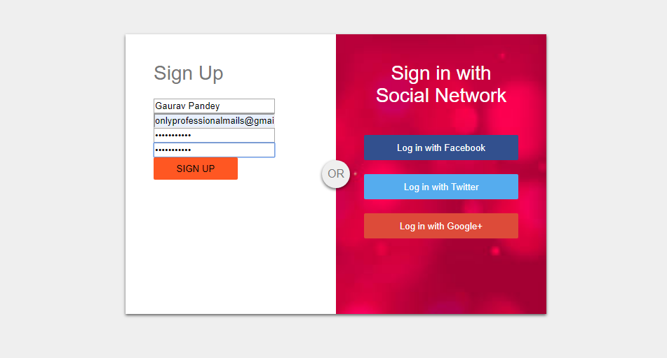

E X P L O R E M O R E

This is main page of our website because it is linked with almost every page on our website directly or indirectly. This page consists of total six buttons created using anchor tag **<a href=” ”> </a>**  and designed through CSS. A logo is also included in this page same as in the Home page. Below is the brief description of each button their uses and their links with the other page.

1. **HOME:** It is active button and first button in the navigation bar.
2. **CONTACT US:** It is the second button in navigation bar. It will direct the user to contact us page.
3. **SERVICES:** It is the third button in the navigation bar. It will direct the user to our service page.
4. **FAQ:** It is the fourth and last button in the navigation bar. It will direct the user to our FAQ section .
5. **STAMP SELLING:** This option is for that user who wants to sell stamps on our website.
6. **STAMP BUYING:** This option is for the users who want o buy stamps from our website.

Below is the preview of this page:

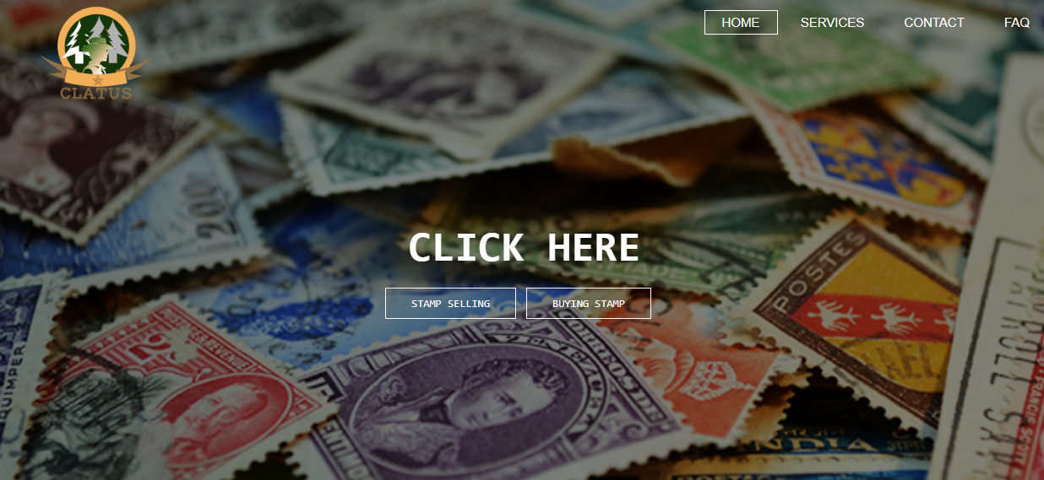

C O N T A C T U S

This page is designed for the user to interact with our team. This page is created by using **<form></form>** tag. It includes three fields and one submit button whose name is”**SEND MESSAGE**”.

This button will direct the user to explore page HOME section.

Preview of the page is shown below:

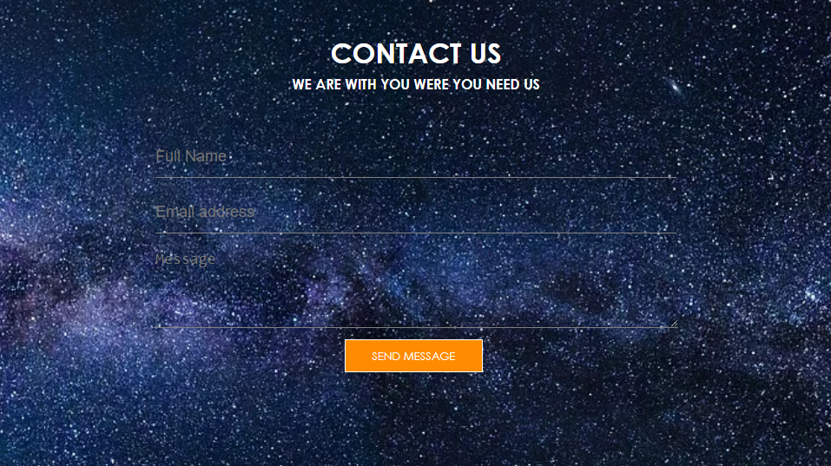

S E R V I C E S

This page is designed to provide user information regarding our website. Information will be regarding our services which we provide. It is created using grids and edited by CSS. A hover effect is given to each box by using CSS.

Preview of this page is shown below:

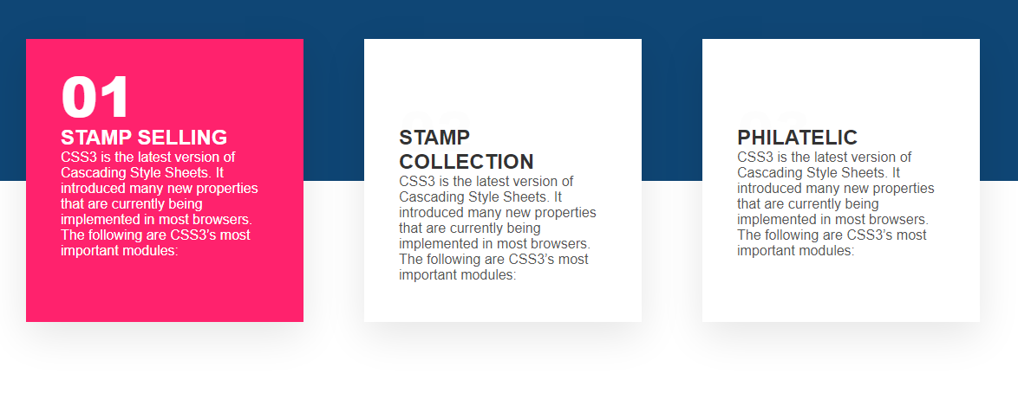

F A Q P A G E

This page is created to provide user information regarding Philately. This page is designed with the help of Java Script and CSS.

We used unordered list in our program. We applied background image in this page.

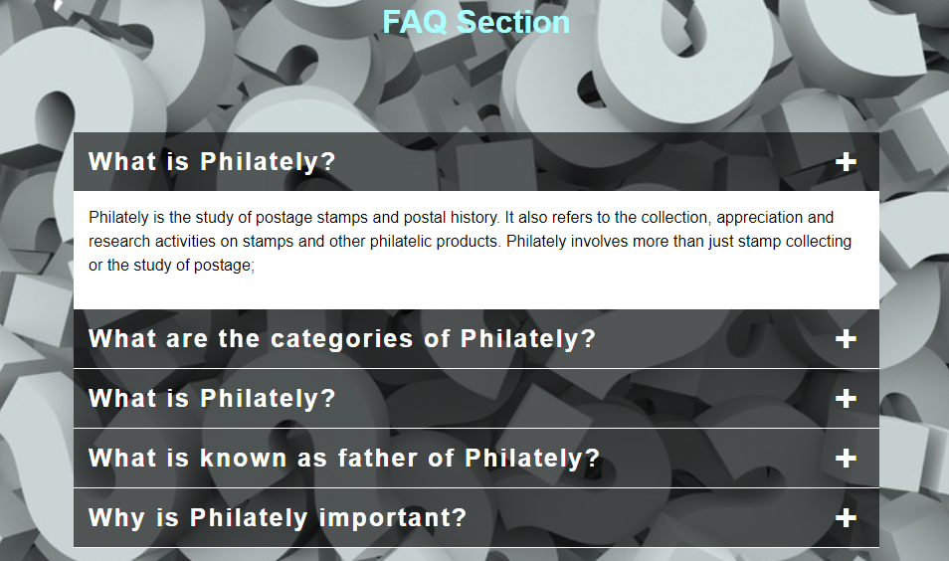

S E L L I N G S T A M P S

This page is designed for our user who wants to sell their stamps on our website. We created this page with the help of **<form></form>** tag and few concept of Java Script is also used in this page for downloading the details entered by the user.

Preview of this page is shown below.

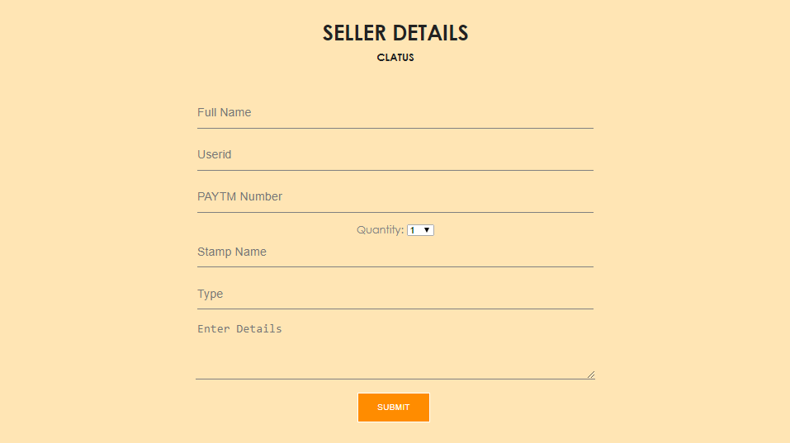

B U Y I N G S T A M P S

This page is designed to those users who want to buy stamps from us. In this page a list of stamps are mentioned among which they can select their stamps which they want to buy and click on **BUY NOW** to move to the payment page.

Preview of this page is shown below:

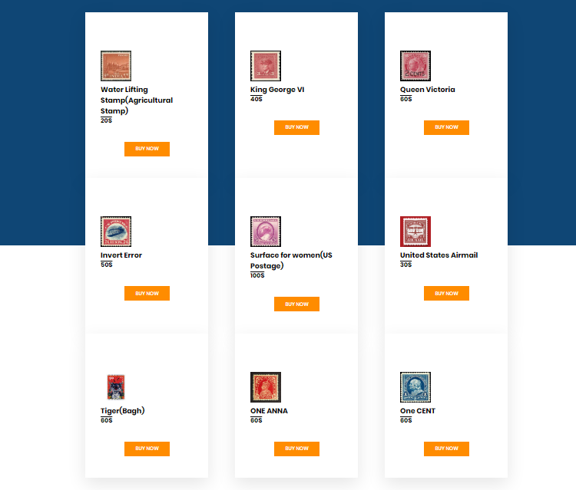

P A Y M E N T P O R T A L

This is the page after the Stamp buying page. It’s for payment purpose for the user who will buy stamps from us. This is again created with HTML and designed through CSS and a concept of Java Script is used to download the details entered by the user as a proof for their payment.

Preview of this page is shown below:

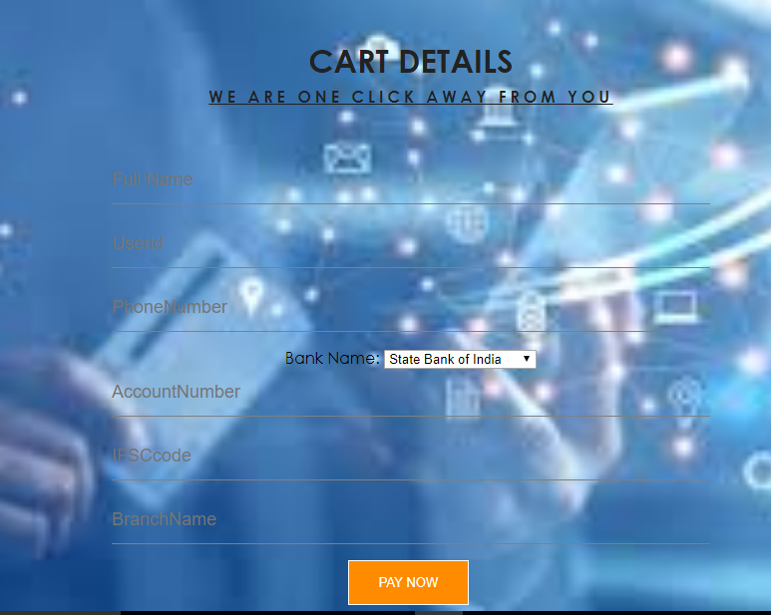

**CODE DESCRIPTION**

As mentioned in our introduction that we used HTML, CSS and Java Script and few concept of J query in this project.

Concept of Java Script is used to download the details entered by the user. We create variable to store the details entered by the user and we use those variables to transfer those details into the text file.

Concept of J query is used to design the FAQ page. It’s used only for designing purpose only.

Below is the image of a Java Script code:

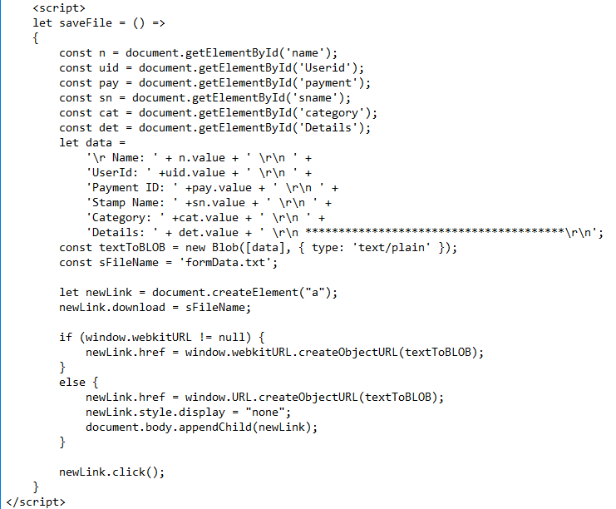

**CONTRIBUTION**

This project is ‘**STAMP COLLECTION WEBSITE**’ which is a group project . A group of three students are working on a single project.

This project is single handily made by Gaurav Pandey. All the coding and the final report is designed by Gaurav Pandey.